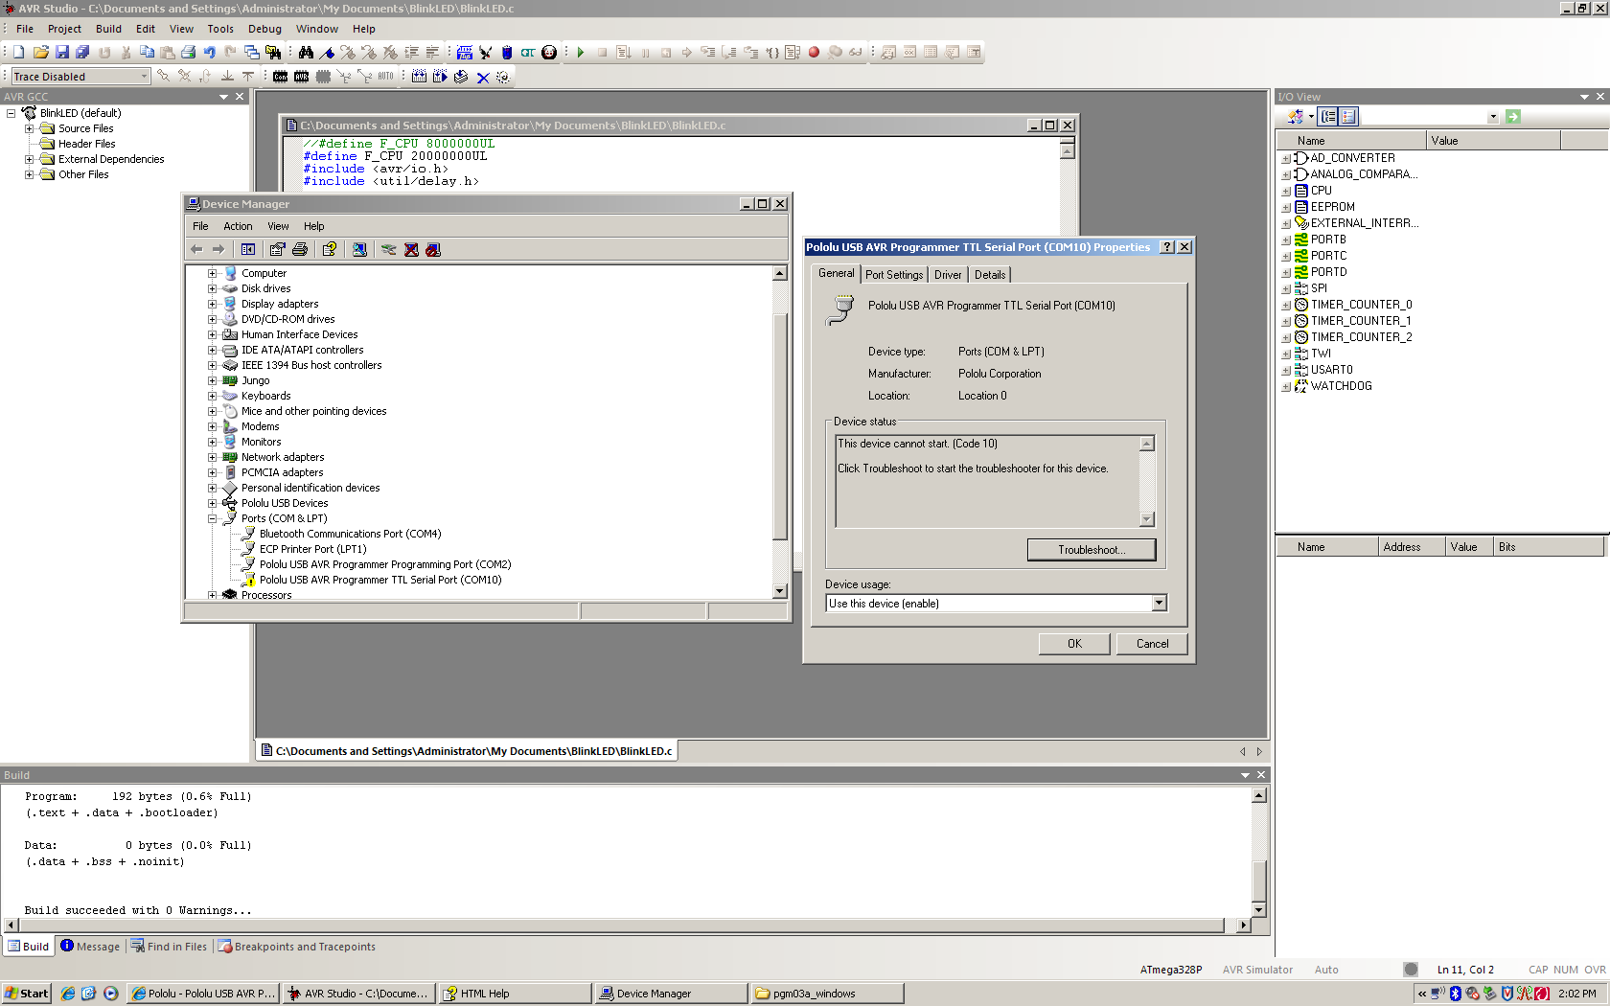
Hi When I go to connect to the Dialog this is what shows up, can you please let me know what I am doing wrong . Thank you for your time. You can contact me at this email: Raymond.bey@gmail.com.
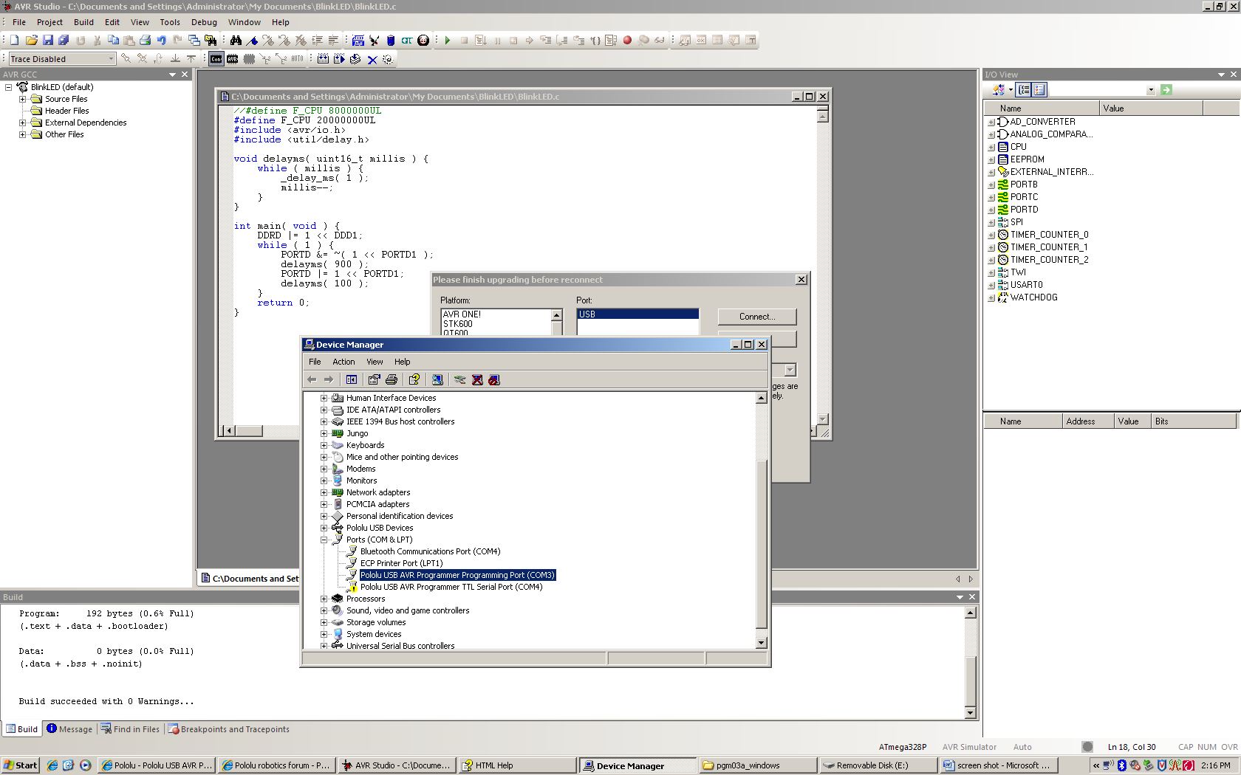
Ive changed the ports to a similar post and still have the same problem.

