X pointing approximate geographic north
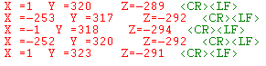

X pointing approximate geographic east
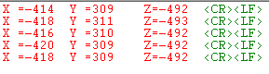

X pointing approximate geographics south

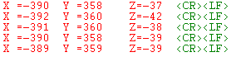

X pointing approximate geographic west

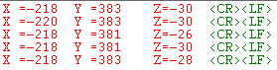

Rotating around the X axis

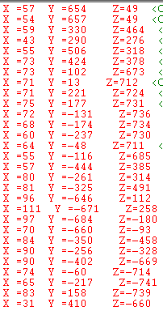

int play=0;
for(play=0;play<7;play++)
{
in_buffM[play]=ByteRead(MAGNET,MR_REG_M+play);
}

X_Mag=(in_buffM[1] << 8) + in_buffM[2];
Y_Mag=(in_buffM[3] << 8) + in_buffM[4];
Z_Mag=(in_buffM[5] << 8) + in_buffM[6];

Rotating around the Y axis
